Auth

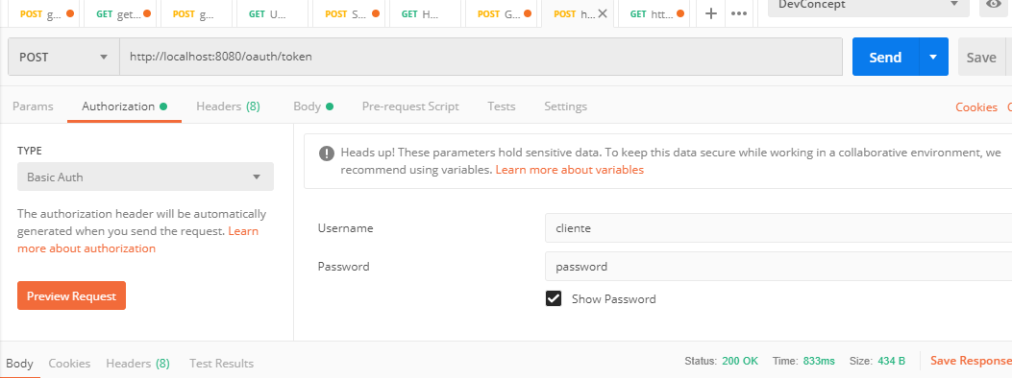

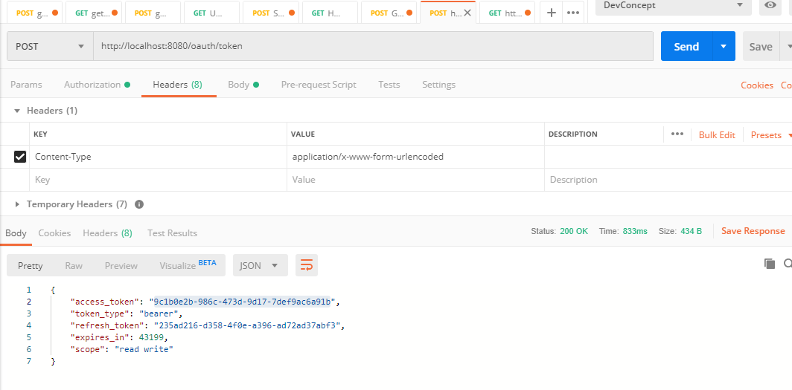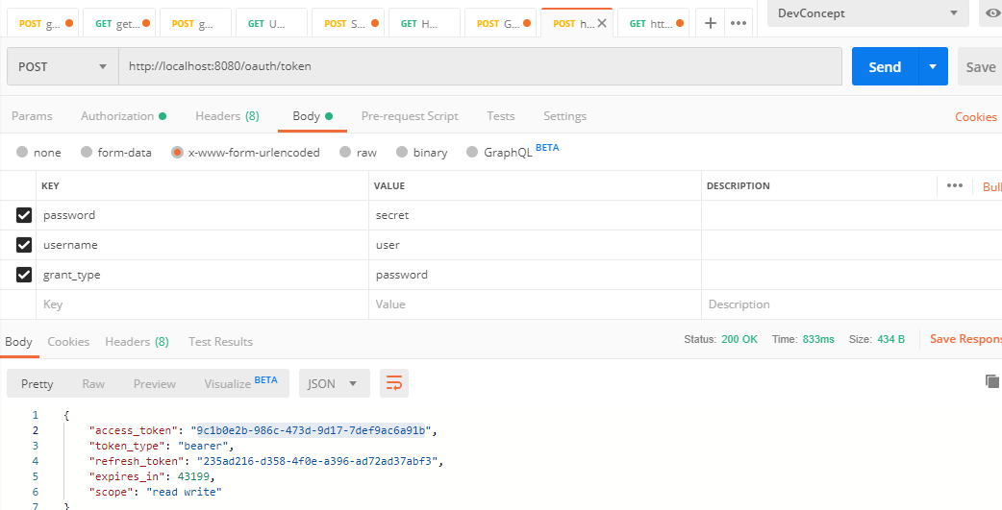

CrediInfo

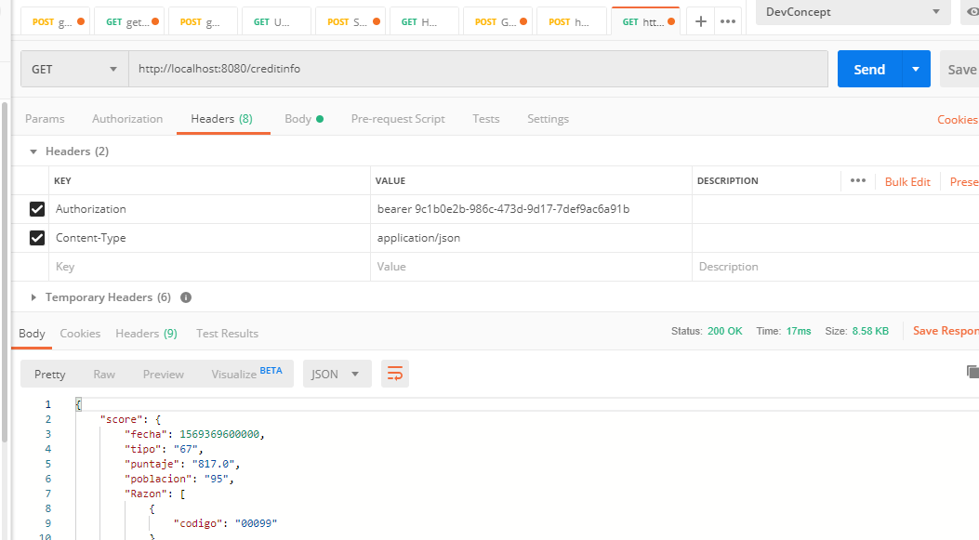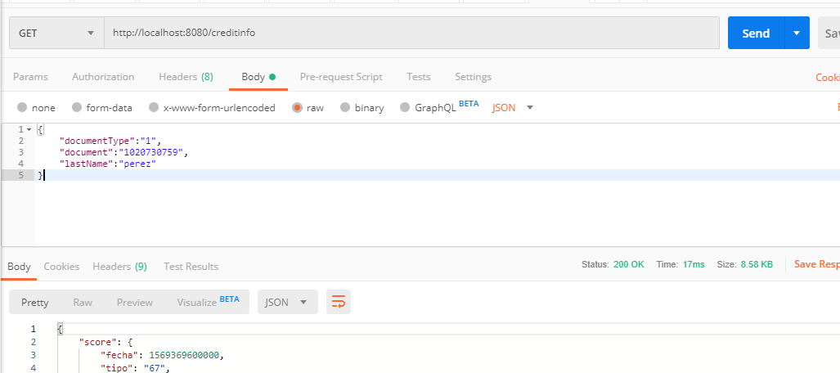

Request de prueba

{

"documentType":"1",

"document":"1020730759",

"lastName":"perez"

}

{

"document": "79628749",

"documentType": "1",

"lastName": "lozano"

}

{

"document": "1020730759",

"documentType": "1",

"lastName": "perez"

}